**Nick Nath**

**Module 9 Data Analysis**

* List the employee number, last name, first name, sex, and salary of each employee.

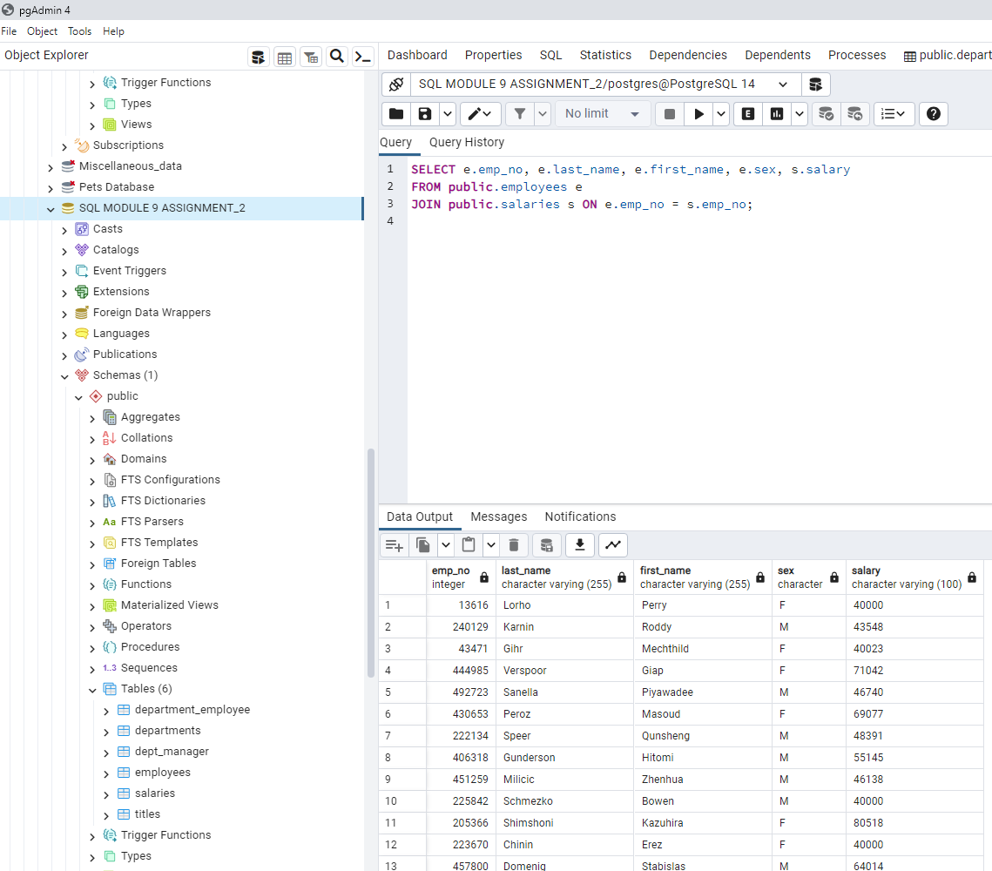

* List the first name, last name, and hire date for the employees who were hired in 1986.

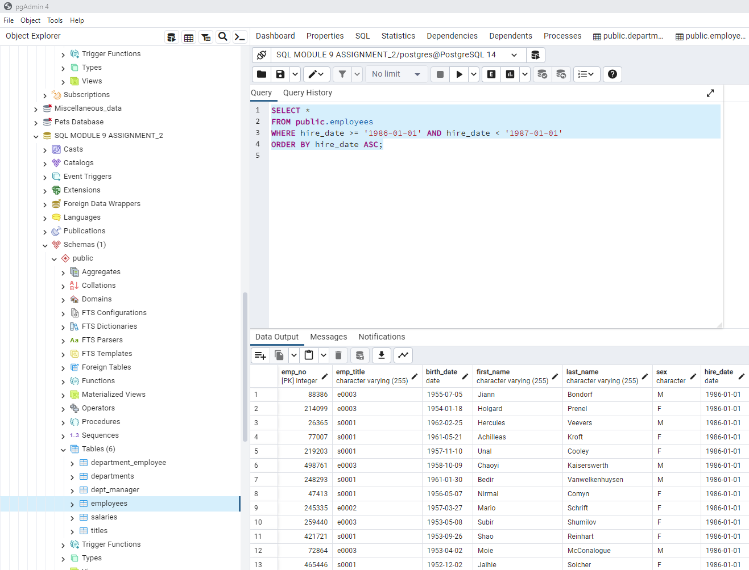

* List the manager of each department along with their department number, department name, employee number, last name, and first name.

* List the department number for each employee along with that employee’s employee number, last name, first name, and department name

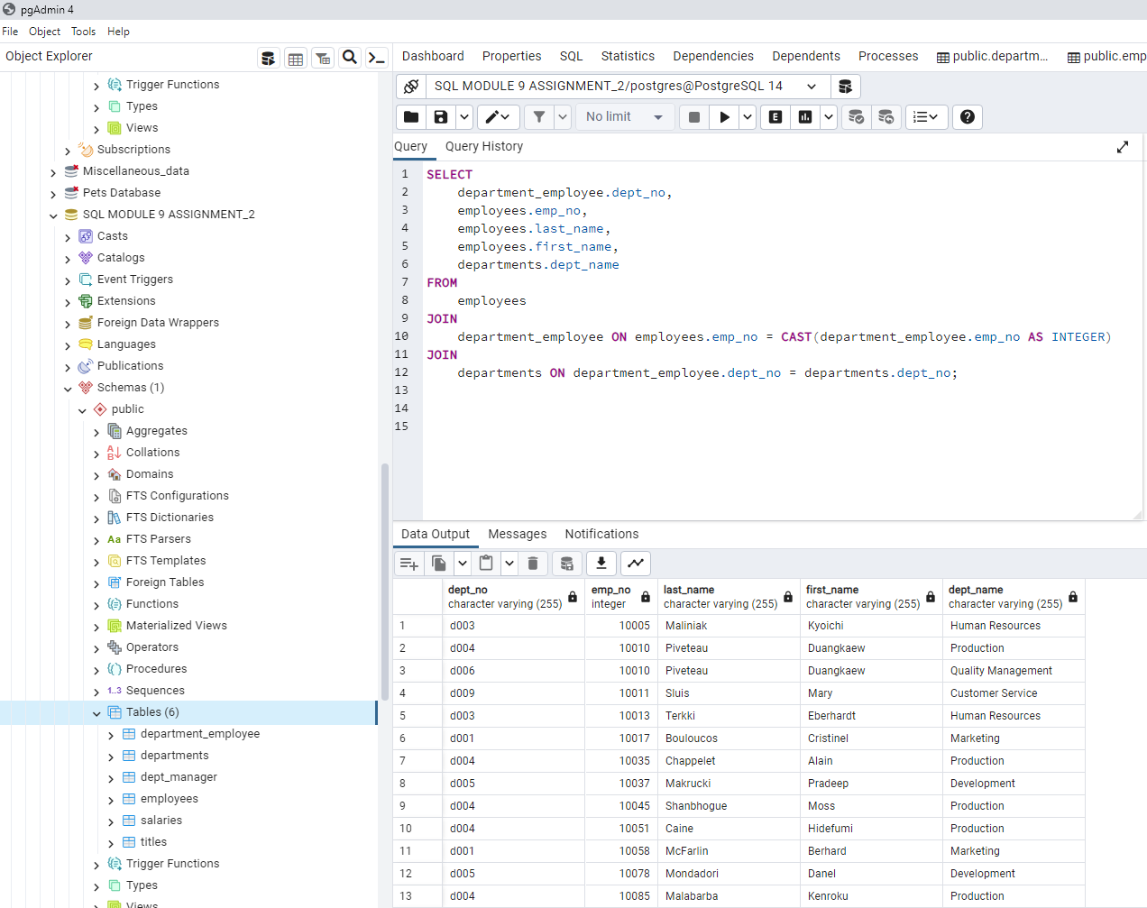

* List first name, last name, and sex of each employee whose first name is Hercules and whose last name begins with the letter B
* List eac 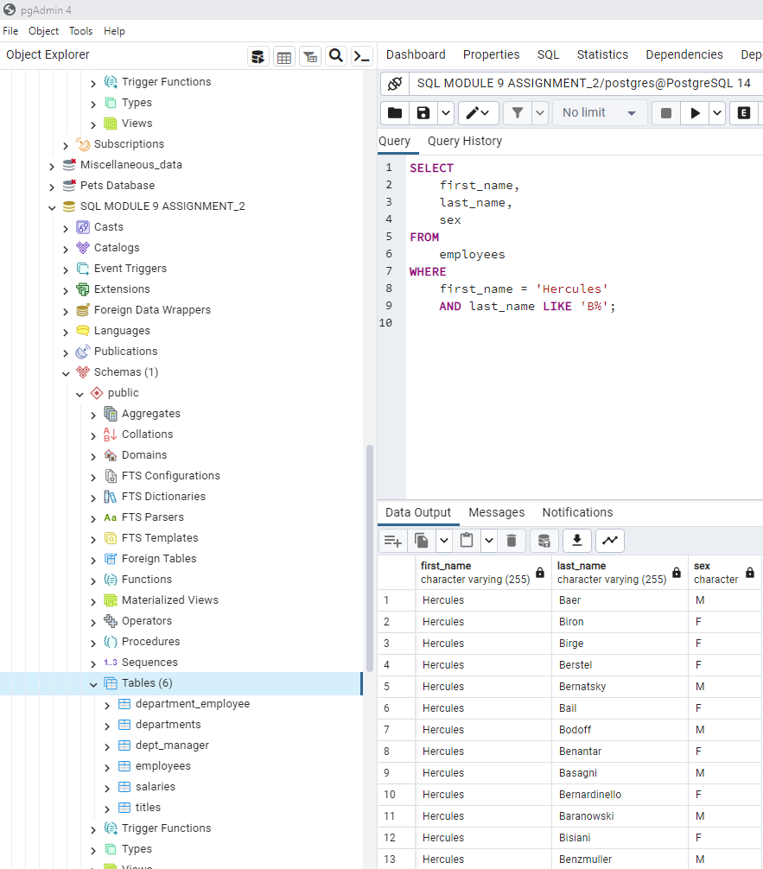
* List each employee in the Sales department, including their employee number, last name, and first name

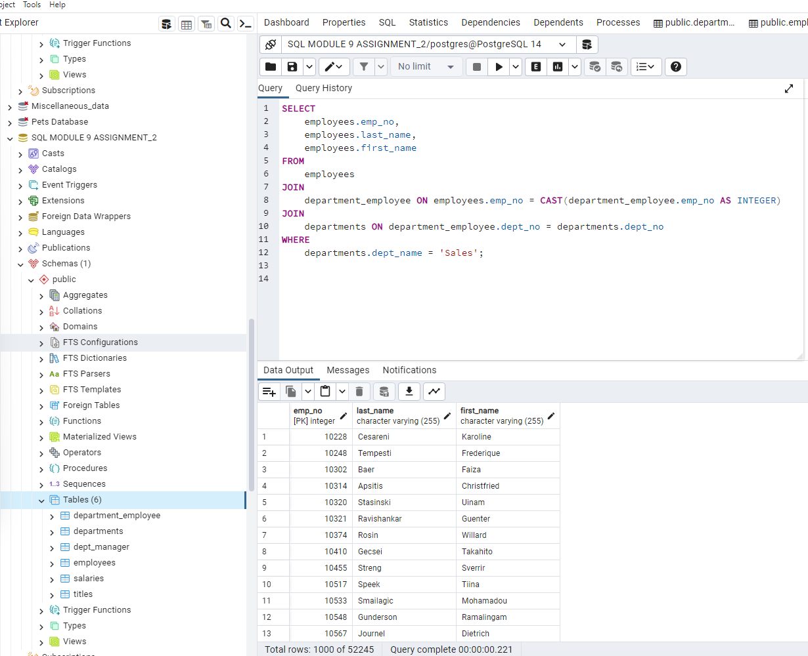

* List each employee in the Sales and Development departments, including their employee number, last name, first name, and department name

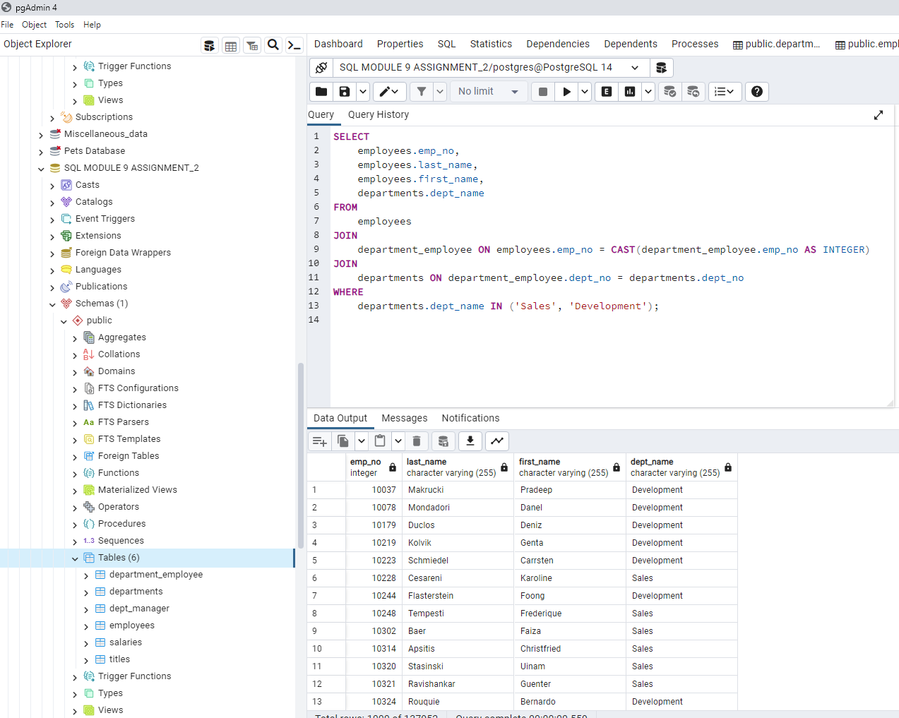

* List the frequency counts, in descending order, of all the employee last names (that is, how many employees share each last name)

